**Sprint 1 - Endurance Design Document**

March30**, 20**20

Use this Requirements Specification template to document the requirements for your product or service, including priority and approval (Must do).

This document will also serve as a System Design Document (How to) and will include sections detailing system flow, algorithms, staffing plan, software/hardware, and Test Plan

This document contains instructions and examples which are for the benefit of the person writing the document and should be removed before the document is finalized.

To regenerate the TOC, select all (CTL-A) and press F9.

**Table of Contents**

**1.** **EXECUTIVE SUMMARY 3**

1.1 Project Overview 3

1.2 Purpose and Scope of this Specification 3

**2.** **PRODUCT/SERVICE DESCRIPTION 3**

2.1 Product Context 3

2.2 User Characteristics 3

2.3 Assumptions 3

2.4 Constraints 3

2.5 Dependencies 4

**3.** **REQUIREMENTS 4**

3.1 Functional Requirements 5

3.2 Security 5

*3.2.1* *Protection 5*

*3.2.2* *Authorization and Authentication 6*

3.3 Portability 6

**4.** **REQUIREMENTS CONFIRMATION/STAKEHOLDER SIGN-OFF 6**

**5.** **SYSTEM DESIGN 6**

5.1 Algorithm 6

5.2 System Flow 6

5.3 Software 6

5.4 Hardware 6

5.5 Test Plan 7

5.6 Task List/Gantt Chart 7

5.7 Staffing Plan 7

# Executive Summary

## ***Project Overview***

Describe this project or product and its intended audience, or provide a link or reference to the project charter.

**The purpose of this project is to successfully travel around the periphery of HH208 and have the robot speak at specific times.**

## ***Purpose and Scope of this Specification***

Describe the purpose of this specification and its intended audience. Include a description of what is within the scope and what is outside of the scope of these specifications. For example:

The purpose of this specification is to identify an intended audience so the work does not go unnoticed. It is also to display what a robot can do.

**In scope**

* **The code that makes the robot move**
* **The route the robot will take**
* **When the robot will start**
* **When the robot will stop**
* **Intended audience: programmers, developers, students, professors**

**Out of Scope**

* **The actual data inside the robot**
* **How the robot was built/works**
* **The engineering of the robot**
* **How sphero.edu works**

# Product/Service Description

In this section, describe the general factors that affect the product and its requirements. This section should contain background information, not state specific requirements (provide the reasons why certain specific requirements are later specified).

## ***Product Context***

How does this product relate to other products? Is it independent and self-contained? Does it interface with a variety of related systems? Describe these relationships or use a diagram to show the major components of the larger system, interconnections, and external interfaces.

**The general factors that affect this product are other objects in the way while it makes it runs around HH208. This product is independent because it only relies on itself, not other objects. It interferes with related systems because the robot is programmed to go a specific route. The larger system would be the robot itself, the interconnections would be the code and the external interfaces would be the computer that runs the program.**

## ***User Characteristics***

Create general customer profiles for each type of user who will be using the product. Profiles should include:

* **Developers**
* **Students**
* **Professors**
* **Programmers**

## ***Assumptions***

List any assumptions that affect the requirements, for example, equipment availability, user expertise, etc. For example, a specific operating system is assumed to be available; if the operating system is not available, the Requirements Specification would then have to change accordingly.

**If HH208 is not available then that assumption would affect the requirements since the robot has to go around HH208. If the user is unfamiliar with how to program the robot then that can affect the requirements as well since the robot would not be successfully programmed.**

## ***Constraints***

Describe any items that will constrain the design options, including

* **A working computer**
* **A computer with enough storage**
* **A computer with internet**
* **A computer with proper battery life**
* **A working robot/charged**
* **Access to sphero.edu**

## ***Dependencies***

List dependencies that affect the requirements. Examples:

* **Code need to match requirements**
* **Intended audience needs to be accurate**
* **Sprint 1 needs to be completed before Sprint 2**
* **Sprint 2 needs to be completed before Sprint 3**

# Requirements

* Requirements:

**Robot must travel around HH208**

**Robot starts at provided yellow square**

**Robot should start with a green light and say “ready set go”**

**Robot should stop with a red light and say “I’m done and I need water”**

**Robot must travel to each yellow floor tile and turn right at the center of each tile**

**Robot must return to starting location**

**Robot should not collide with any objects**

## ***Functional Requirements***

|  |  |  |  |  |  |
| --- | --- | --- | --- | --- | --- |
| **Req#** | **Requirement** | **Comments** | **Priority** | **Date Rvwd** | **SME Reviewed / Approved** |
| ENDUR_01 | Robot must travel around HH208 | none | yes | 3/29 | Everyone |
| ENDUR_02 | Robot starts at provided yellow square | none | yes | 3/29 | Everyone |
| ENDUR_03 | Robot should start with a green light | must say “ready set go” | yes | 3/29 | Everyone |
| ENDUR_04 | Robot should stop with a red light | must say “I’m done and I need water | yes | 3/29 | Everyone |
| ENDUR_05 | Robot must travel to each yellow floor tile | must turn right at the center of each tile | yes | 3/29 | Everyone |
| ENDUR_06 | Robot must return to starting location | none | yes | 3/29 | Everyone |
| ENDUR_07 | Robot should not collide with any objects | must be a flawless demo | yes | 3/29 | Everyone |

## ***Security***

### **Protection**

Specify the factors that will protect the system from malicious or accidental access, modification, disclosure, destruction, or misuse. For example:

* encryption
* proper passwords
* peer review from other group members
* should be saved and backed up

### **Authorization and Authentication**

Specify the Authorization and Authentication factors. Consider using standard tools such as PubCookie.

## ***Portability***

If portability is a requirement, specify attributes of the system that relate to the ease of porting the system to other host machines and/or operating systems. For example,

* **Save project on computer so access is always available**
* **Screenshot code to share with group members**
* **Send project file to group members**
* **Make sure sphero.edu can run on multiple OS**

# Requirements Confirmation/Stakeholder sign-off

Include documentation of the approval or confirmation of the requirements here. For example:

|  |  |  |
| --- | --- | --- |
| **Meeting Date** | **Attendees (name and role)** | **Comments** |
| 3/29/20 | Tom | confirmed |
| 3/29/20 | Meghan | confirmed |
| 3/29/20 | Tyrone | confirmed? |

# System Design

This section will provide all details concerning the technical design, staffing, coding, and testing the system

## ***Algorithm***

Develop and describe here the algorithm that will be used to provide the required performance of your software

* **Change light to green**
* **program robot to say “ready set go” and wait until next command**
* **Roll at 90 degrees at 50 speed for 3 seconds**
* **delay for 1 second**
* **roll at 180 degrees at 50 speed for 3 seconds**
* **delay for 1 second**
* **roll at 270 degrees at 50 speed for 3 seconds**
* **delay 1 second**
* **roll at 0 degrees at 50 speed for 3 seconds**
* **Once finished, change light to red**
* **program robot to say “I’m done and I need water”**
* **exit program**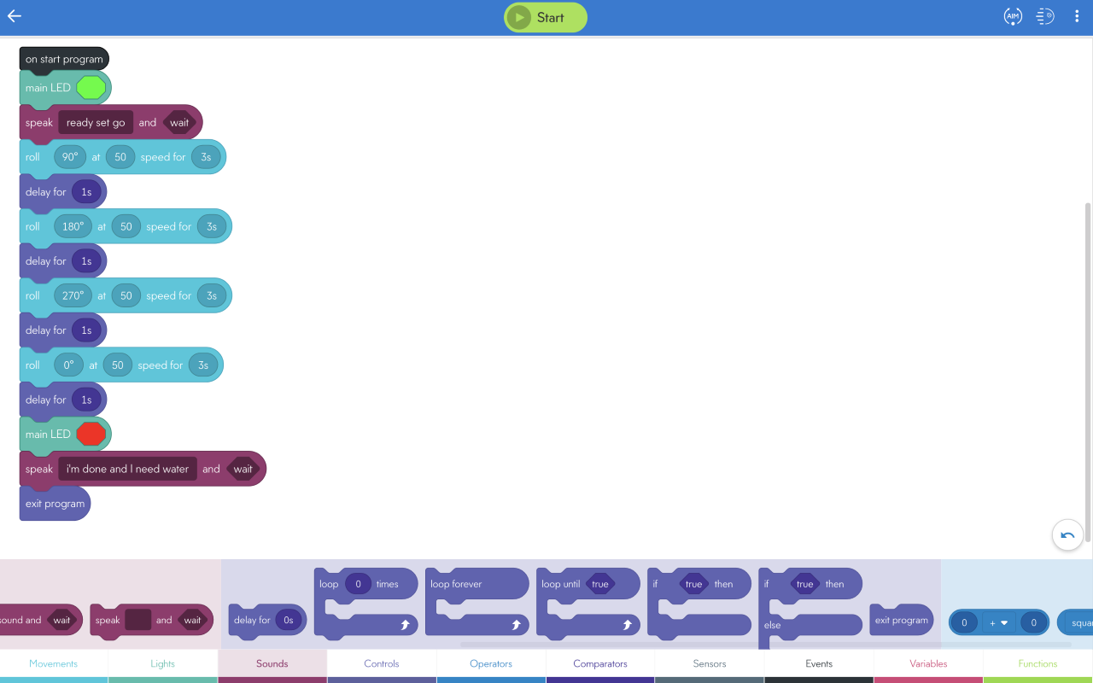

## ***System Flow***

Develop a flowchart (and show here) that accurately depicts how your software application will act to fulfill the algorithm

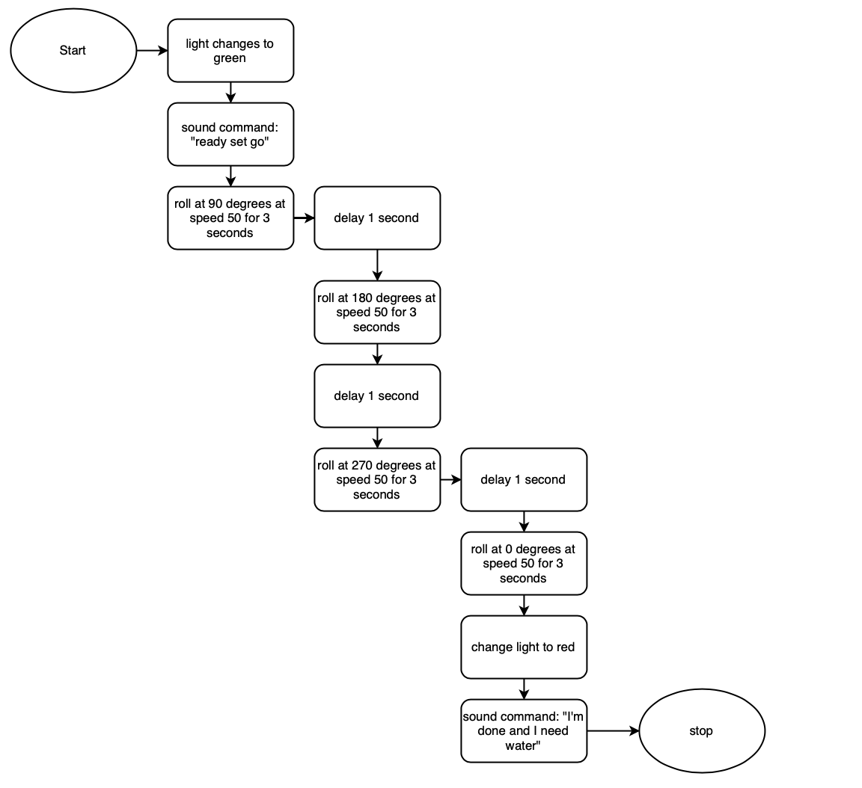

## ***Software***

Describe software languages/platforms/api’s used to develop and deploy this application

**We are using sphero.edu**

## ***Hardware***

Describe hardware platforms that were used to develop, test and demonstrate this application

**We are using a macbook Pro to develop, test and demonstrate**

## ***Test Plan***

Include a test plan showing all unit tests performed for this application, Include test rational, test date, staff member, pass/fail status

|  |  |  |  |  |  |
| --- | --- | --- | --- | --- | --- |
| **Reason for Test Case** | **Test Date** | **Expected Output** | **Observed Output** | **Staff Name** | **Pass/Fail** |
| shape | 3/29/20 | square formation | square | Meghan | pass |
| speed | 3/29/20 | constant speed | too slow | Meghan | fail |
| degree | 3/29/20 | 90 degree right turns | 90 degree right turns | Meghan | pass |
| flow | 3/29/20 | good movement | needed pause at each right turn | Meghan | fail |
| color | 3/29/20 | green at start, red at finish | green at start, red at finish | Meghan | pass |
| sound | 3/29/20 | 2 sound commands | completed both | Meghan | pass |

## ***Task List/Gantt Chart***

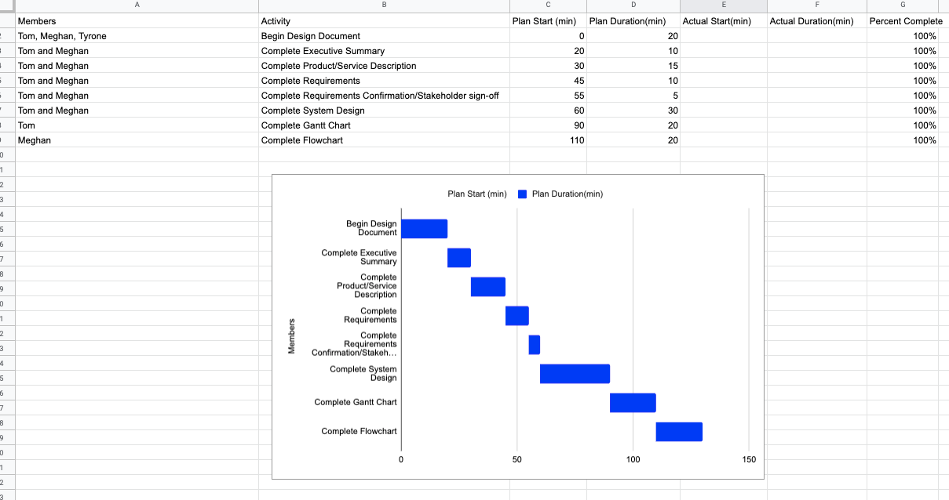

## ***Staffing Plan***

Insert a chart/table that depicts the roles and responsibilities of each team member that worked on this project

|  |  |  |  |
| --- | --- | --- | --- |
| Name | Role | Responsibility | Reports To |
| Meghan | code | writing and testing program code, system design template | Tom |
| Tom | System design | algorithm, system design template | Tom |
| Tyrone | ?? | ?? | everyone |